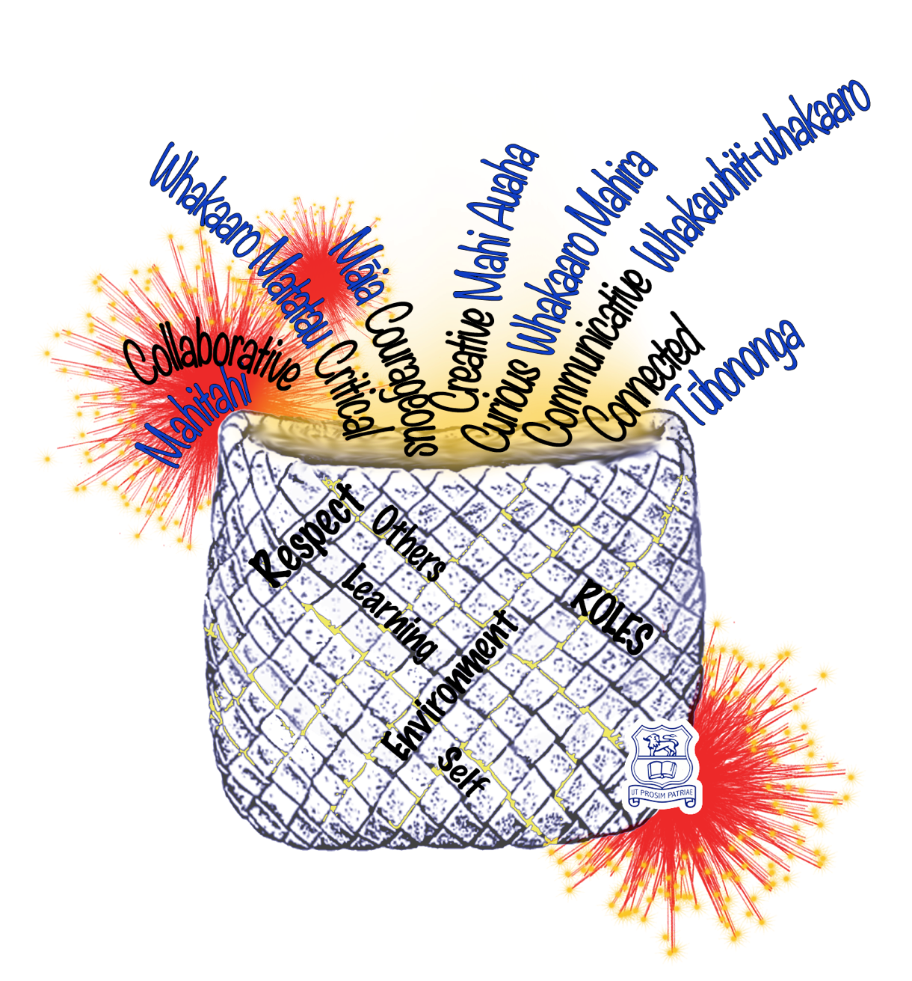
Thames High School
Te Kura Tuarua O Kauaeranga

Year 10
Junior course information Booklet 2021

Curriculum Structure
Kete, HIP & Core Descriptions
Stationery & Digital Devices

Junior Curriculum (Year 10)
There is 4 parts to the timetable for all Year 10 taiohi (students):
 | Time allocation in the timetable | Description of course. | Notes
Part 1: Pastoral/ Guidance - Rōpū | - Rōpū time  15 minutes Monday, Thursday and Friday after period 1.  - Learning Advisory (LA)  25 minutes on a Tuesday and Wednesday after period 1. | Taiohi (students) will meet with their rōpū kaitiaki (pastoral teacher) everyday. This time is very valuable to ensure students have all the information and resources they need for a successful day, as well as to develop an educational plan for each taiohi and to ensure that each taiohi is achieving at the best of their ability. The rōpū kaitiaki is the first point of contact for parents. | Hours per week for this area:  - 15 minutes after period 1 on Monday, Thursday and Friday.  - 25 minutes on a Tuesday and Wednesday - This is also where assembly will happen.  - This equates to 95 minutes each week.
Part 2: Cross-curricular learning kete  Kete classes descriptions in Appendix 1. | Kete Classes are 75 minute periods, 3 times a week.  There will be Four (4) Kete that will run for the duration of two terms. Each taiohi, in their timetable, will have Two (A or B) Kete in Term 1 and Two (A or B) in Term 3 and 4.  2021 - Kete learning areas  Kete 1A - English and Music  Kete 1B -Digital Technology and PE  Kete 2A - English and Drama  Kete 2B - Math and PE. | Cross-curricula courses are designed to be high-interest and authentic learning experiences that include two or more curriculum areas. Taiohi will participate in each module offered throughout the year in their Rōpū class.  An example of a class:  What’s in a Game.  A combination of PE and Social Studies where students experience games from a variety of different cultures. Taiohi will investigate and participate in a range of games with a further in depth study on one game. | Hours per week for Kete and compulsory courses:  - Kete and Compulsory /Core courses have 3x 75 minute periods each week.  - This means that for a kete class or compulsory course they will have 3.75 hours each week.  - Compulsory courses 1 and 2 (as above) run for 2x terms per subject with Compulsory course 3 running for 1x term per subject.
Part 3: HIP - High Interest Projects/extension and accelerated learning programmes  HIP classes descriptions in Appendix 2. | Each Taiohi will have Two (2) HIP classes each term as part of their timetable. Taiohi, along with whᾱnau support, will be able to make a selection by ranking the 8 HIP courses on offer. | During this time taiohi will be involved in group or individual projects that reflect their interests. There are 8-9 different classes that a taiohi can choose from each term. The project will run for one term and taiohi are recommended to select a different class each term. Each class has a different focus and may include extension or accelerated learning programmes. All classes have a project they are contributing to or creating. For example in the class called  “Enterprising”, the class is working with business mentors from our community to create a product to potentially sell at the Thames Market. This requires students to engage in the planning, marketing, producing and selling of a product. | Hours per week for this area:  - HIP class Line 6 will have 3 times 75 minute classes each week (3.75 hours each week)  - HIP Line 7 will have 2 times 75 minute classes each week.  - These HIP classes are grounded in a curriculum area.  - Taiohi are working on a project or performance in this class.  - Both Year 9 and Year 10 Taiohi working together.

Part 4: Compulsory / Core courses
 | Compulsory Course 1 | Compulsory Course 2 | Compulsory Course 3
Classes are 75 minute periods, 3 times a week which Taiohi will attend with their Rōpū class. This equates to 3.75 hours each week per class. (x3)  Compulsory courses are designed to include key knowledge of the learning area. | - Science  - Math  Each rōpu will attend one subject for two consecutive terms. ie: Term 1& 2 = Math, Term 3 & 4 = Science. | - English  - Technology  - Math  - Health and PE  Each rōpu will attend one subject per term. | - Social Studies  - English  - Music  - Te Reo Maori  Each rōpu will attend one subject per term.
The New Zealand Curriculum has 8 learning areas: English, The Arts, Science, Mathematics, Languages, Social Sciences, Technology and Physical Education/Health. All of the learning areas appear in the Kete and Compulsory lines. Students will cover all curriculum areas (7 of them) throughout the year.
[Subjects and 2021 information is subject to change.]
Core
Compulsory / Core courses

Core classes are made up of 9 subjects that teach the key skills in that Learning area, identified below. Each ‘Core’ subject will either run for one or two School Terms, which will be attended by taiohi in their rōpū class. Taiohi will have on their timetable 3 ‘Core’ subjects/courses at any one time. The changeover and structure is outlined below.

Compulsory Course 1 | Compulsory Course 2 | Compulsory Course 3
- Science  - Math  Each rōpu will attend one subject for two consecutive terms. ie: In Terms 1& 2 taiohi will have Math then in Term 3 & 4 they will have Science. | - English  - Technology  - Math  - Health and PE  Each rōpu will attend one subject per term.  The Compulsory courses will change over at the beginning of each Term.  An example would be:  Term 1-Math  Term 2- English  Term 3-Technology  Term 4- Health and PE | - Social Studies  - English  - Music  - Te Reo Maori  Each rōpu will attend one subject per term.  The Compulsory courses will change over at the beginning of each Term.  An example would be:  Term 1- Social Studies  Term 2- English  Term 3- Te Reo Maori  Term 4- Music

Stationary and Digital Devices

Please check our school website for the Year 10 stationary requirements. Link
Kete
Cross-curricular learning
In 2021 each Taiohi will experience all Kete on offer, and therefore no selections will be made. Below is an outline and description of each Kete. A Taiohi will have 2 Kete on their timetable and the kete will run for two Terms.
Taiohi will attend the Kete as part of their Rōpū class along with one other Rōpū class. This will be kept consistent across all Kete. The kete are defined as “Kete 1 (A or B)” and “Kete 2 (A or B)” but will show a unique code on the students timetable that reflects the name of the Kete.
Kete 1 (A and B)
Course Code on Timetable: SING | Title: Sing a Dream  Subjects: English and Music | Course Code on Timetable: PTL | Title: Play to Learn  Subjects: Digital Technology and PE
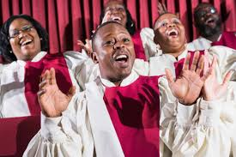 | Students will explore gospel music as a vehicle that African-American people used to express their frustration with the social and political conditions they were subjected to, and which led to the struggle for civil rights. They will analyse songs from this context as a basis for developing their own song-writing and practical performance skills. They will then submit a piece of creative writing and set this to music. | 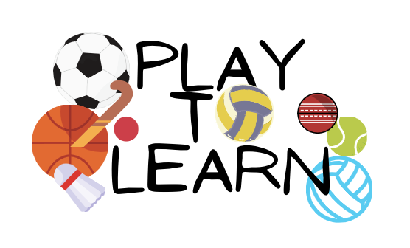 | “Play to Learn” Sporting events on a small scale, emphasis on precision, analysis, performance and problem-solving. For these events to be successful: planning, instructions, advertising, recording, evaluation, and review are required. This will occur through learning physical skills, working together, designing and creating digital outcomes.  Participation is a focus within all projects whether in the classroom, gym, pool or field.

Kete 2 (A and B)
Course Code on Timetable: TLG | Title: Through the Looking Glass  Subjects: English and Drama | Course Code on Timetable: FHS | Title: Faster, Higher, Stronger  Subjects: Math and PE
 | As human beings we communicate in a variety of ways. Visual communication has become a dominant method of communication with the ever increasing use of technologies.  Tauira will develop their understanding of film genre, aspects and techniques; and will develop their skills in critiquing by viewing a range of visual texts. .  Drama, be it live theatre, street theatre or film is a way of creating visual text. Tauira will discover that as a visual text, drama not only allows us to see human history but also create and define history.  Using the skills tauira will gain in this kete they will produce a competent formal film review and a short film. |  | Students will learn to apply the mathematics skills of angles, statistics, bearings and scale drawing to a practical setting in PE to analyse and improve performance. Students will then create a frisbee or football golf course and then apply biomechanics principles to successfully complete the course.
HIP
High Interest Projects/extension and accelerated learning programmes

High Interest Projects and the course description are indicated below. Each student will have the opportunity to make a selection by ranking the courses for each of the two lines - Line 6 and Line 7 (via a google form sent to their school email). This selection will then be the basis of how students are organised into their HIP classes for the year. The timetable will endeavour to place students in classes so they experience their first choice during the year.

HIP (High Interest Project) Course Descriptions for Line 6
Line 6 | Course Title | Course Code: | Course Description | Running time for HIP
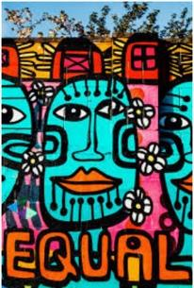 | Making a Mark | MARK | A picture paints a 1000 words. It relates to our whakapapa and our wairua. Art involves critical thinking and practical creativity, making connections to established practice and interpreting experiences, feelings and ideas. Through combining elements of these things we are able to become more confident in our ability to create, communicate and collaborate. This is powerful magic! | 2 Terms
 | Writers Workshop | WRW | Stories of others help us learn about ourselves and our world.  In this HiP we will use the work of writers and directors, both from the past and present and from all over the world to inspire our own writing.  We will use mini-lessons, independent time and collaboration to continue building our skills and confidence with writing. | 2 Terms
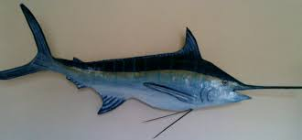 | Moana Mask and Model Making | MOA | Learn to plan and design, create and make a small sculpture, mask or manaia which captures the uniqueness of our place on the Firth of Thames. We will be working with a variety of materials (multi-media) that will enable you to complete your own take home 3D sculpture. | 1 Term
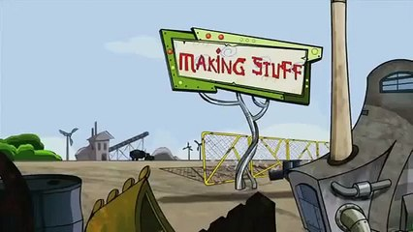 | Transformers | TFM | Come and learn how to design and make projects. Use a range of different materials including wood, metal, plastic, electronics, programming and CAD software and manufacture to make your ideas. | 1 Term
Line 6 Cont.
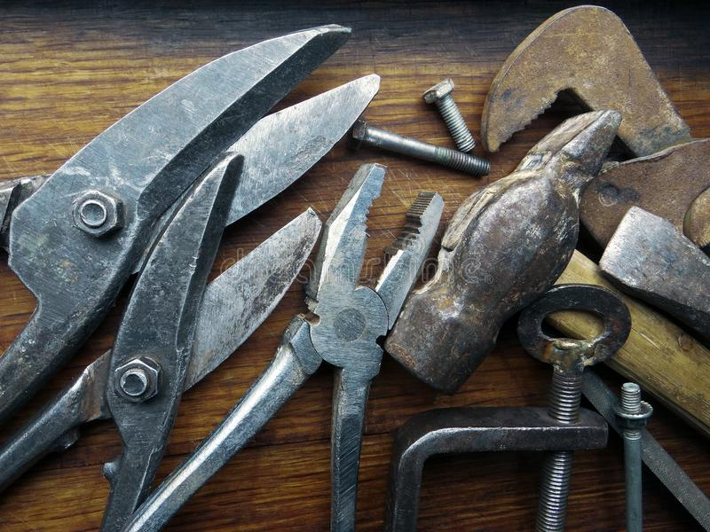 | Back to basics | B2B | Learn how to use and maintain workshop tools while creating a project that has some moving parts. Become proficient in working with metal, and experiment with how it can be used in a variety of ways. | 1 Term
 | Best Of The Bunch | BOTB | This is an opportunity for girls to come together and decide what experiences or coping mechanisms add to being a better version of themselves.  We will explore health and wellbeing options in a positive and encouraging way. These options could include better nutrition and fitness, and discovering new practical life skills. This course will be a mix of practical and classroom experiences that will be heavily driven by the students interests. This will be ideal for girls who are interested in discovering what we can do to be the best version of ourselves and contributing back into the community! (This course is for Female students only) | 1 Term
 | Creative Materials | CMT | Come and work with fabric and other materials to create items you have helped to design and have an interest in.  This course is largely driven by you, so you can develop your own ideas and passions whilst learning skills to last a lifetime.  Garment construction,tie dyeing, plushies (toys)sport bags and gifts are some ideas.  DIFFERENT CRAFT OPTIONS CAN BE OFFERED if you want to do something you already have a passion for. eg crochet, knitting or patchworking.. even needle felting. Projects are yours to keep. | 1 Term  (2 terms by negotiation)
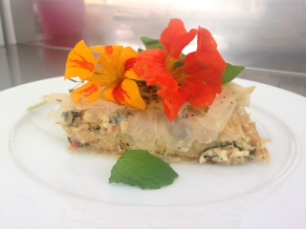 | Kai with heart and soul | KAI | Kai brings people together, nourishes and forms part of our human identity. Food and Hospitality involves using practical processes and techniques to create quality food products that you can proudly share with others. Kai with heart and soul is about working collaboratively and by combining these creative processes you will make interesting and tasty food and beverage products that others will love! | 1 Term
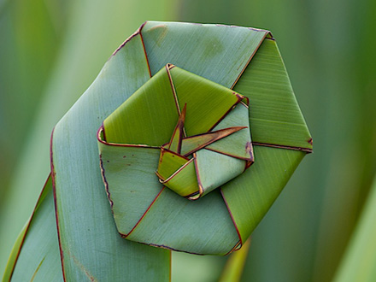 | Ancient Technology | ANT | This HIP focuses on ancient hand crafts such as weaving, carving, outdoor cooking, shelter building and raft construction. Learn something new to do with your hands that isn’t scrolling memes or doing an infinite dab emote. | 1 Term

HIP (High Interest Project) Course Descriptions for Line 7 - Please rank these courses 1-9 using the Google form provided.

Line 7 | Course Title | Course Code: | Course Description | Running time for HIP
 | Stave, Clef, Note | SCN | In this course, students will study musical notation, and learn the basics of music theory. This course is designed to prepare junior students for advanced abstract understandings about music in senior high school. The practical component of the course involves learning reading and playing skills on electronic keyboard. | 1 Term
 | Exposure: Intro to indie film | EXP | In this course, students will take a close look at some great examples of New Zealand film, and use these to inspire their own creations. They will learn simple film techniques, how to create a structured storyboard and then use these new skills to create their own short films to be shared with the class. | 1 Term
 | Real World Coding | CODE | Coding for the real world. Create, code, debug, evaluate for real world objects. No coding experience needed, you just need to be keen to try and challenge yourself. | 1 Term
 | Let Me Have My Say | MySa | Let Me have My Say Students will learn the art of researching and debating issues. Students will take part in a regional debate competition in Tauranga late in the term. | 1 Term
Line 7 Cont.
 | Private Investigations | PI 101 | Science is all about solving problems.  Mrs Scoggins and Mrs Curnow have the problems- can you provide the solutions?  This course will involve group work, scientific practical work and a lot of thinking. | 1 Term (Terms 1 and 4 only)
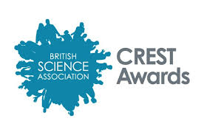 | Bronze crest | CREST | This is an international Scientific award where you can work individually or as a team.  Design, plan, carry out and present a scientific project of your choice. | 1 Term (Terms 2 and 3 only)
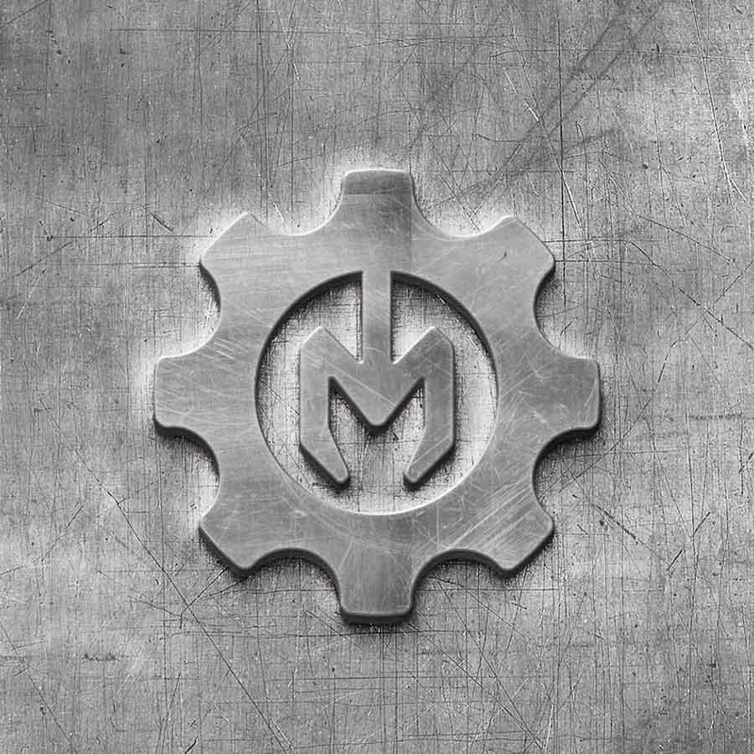 | Mechatronics | TRON | Learn how digital technology and materials technologies can work together to create even more amazing products. Students will make a series of smaller projects during this HIP. | 1 Term
 | World Issues | WIS | In this course students can investigate a real world issue and come up with an innovative solution. The issues might involve sustainability, biodiversity, environmentalism and climate change (both locally and globally.) | 1 Term
 | Fun with logic. | FWL | In this course, students will develop their critical thinking and deductive reasoning skills to complete puzzles in a variety of contexts. These skills can be directly applied to work in most fields of study. | 1 Term

