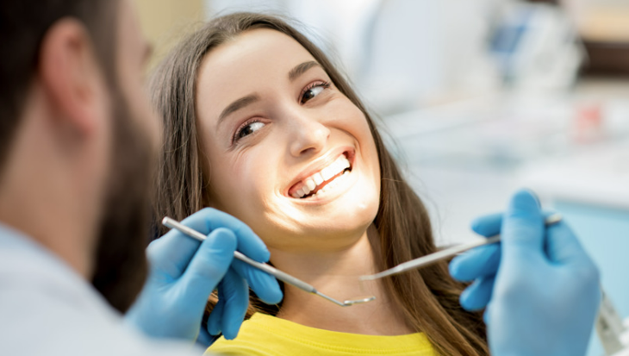

Kia ora parents/guardians at Thames High School ,
Our mobile dental van is coming to the school! Dental care is free for NZ residents under 18 and we provide publicly-funded dental care on-site at many high schools in Auckland, Northland and Waikato. Working in partnership with Te Whatu Ora, our aim is to improve the number of high school students accessing quality dental care.

This is your opportunity to enrol your adolescent with us for their free dental care. We will see students from years 9 to 13 (under 18 years old) for their free dental check-up and treatment.

If your adolescent is currently enrolled with a dental provider, please let us know. Just click the link below and choose the “No” option if you’re happy to stay with them.
When
Our mobile dental unit is visiting Thames High School from 30 Oct till 10 Nov
How
To accept or decline our services, simply click on the link below and follow the prompts.

https://analytics-au.clickdimensions.com/cn/avjqi/onlineenrolment

If you have any trouble accessing the link, please call us on 0800 262 2022 or send an email to mobiles@dentalplanet.co.nz
What do we offer
Your child’s first appointment with us will consist of:
- Full examination of teeth and overall oral health
- X-rays
- Preventive treatments as needed, including:
  - Simple clean
  - Fissure sealants
  - Application of topical fluoride
  - Simple fillings as needed (parental consent may be required)

We will then continue see your child yearly for their dental consultation until their 18th birthday, unless you inform us otherwise.
Why choose Dental Planet
We are long-time members of the New Zealand Dental Association and strictly adhere to best clinical practices and health and safety policies. We operate with the highest level of integrity, safety, efficiency, and privacy.

All Dental Planet staff working in our mobile units undergo in depth training to ensure they are constantly up to date with the current protocols for each school we serve. Police vetting is mandatory and CCTV cameras are positioned inside the mobile units to safeguard both patients and staff.
For students in year 8 and younger
For children in school year 8 or younger, they get seen by the community dental clinics for their regular dental checks (call 0800 TALK TEETH for Auckland/Waikato, 0800 MY TEETH for Northland).
Contact No.
If you have any questions or comments, feel free to contact us on our details below.
We look forward to seeing your child during our visit.

Ngā mihi,

Mobiles Team
Dental Planet
Phone: 0800 262 2022
Email mobiles@dentalplanet.co.nz

